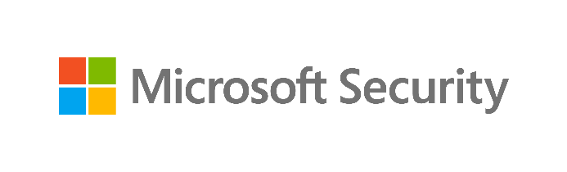

Data Security Envisioning WorkshopData Security Engagement
08-Module Delivery Guide-Communication Compliance
v8.5 - January 2026
Contents
Disclaimer 3
Version history 4
We look forward to your feedback! 4
1 Introduction 5
1.1 Objectives 6
1.2 Delivery guidance 6
1.3 Scoping 7
1.4 Estimated partner effort 7
1.5 Tools and services used 7
1.6 Modular setup, mandatory and optional activities 8
2 Activity details 10
2.1 Step 1 - Kick-off meeting 10
2.2 Step 2 - Acquire and assign licenses 10
2.3 Step 3 - Setup and configuration 11
2.3.1 Assign permissions 12
2.3.2 Confirm privacy settings 14
2.3.3 Set up groups for Communication Compliance 15
2.3.4 Create the Inappropriate text policy 16
2.3.5 Create the Sensitive information policy 17
2.3.6 [Optional] Create the Conflict of interest policy 18
2.4 Step 4 - Analyze the findings 19
2.4.1 Prepare for analysis—exporting the reports and log files 19
2.4.2 Analyzing discovery findings log files and reports 21
2.5 Step 6 - Decommission 24

Disclaimer
The Data Security Envisioning Workshop provides a summary of an organization’s data protection and compliance stature and recommendations to improve data protection and compliance.
The information, results, and scoring provided through the Data Security Envisioning Workshop are recommendations and provided for general informational purposes only. They do not constitute legal advice, certifications, or guarantees regarding regulatory compliance; it is up to each organization to evaluate the effectiveness of these recommendations in their respective regulatory environment prior to implementation. Organizations should consult with their own legal professionals to determine how standards or regulations apply to their organization and how to best ensure compliance.
We hope the Data Security Envisioning Workshop helps identify technologies and additional steps that organizations can implement to simplify their compliance efforts.
MICROSOFT MAKES NO WARRANTIES, EXPRESS, IMPLIED, OR STATUTORY, AS TO THE INFORMATION IN THIS Data Security Envisioning Workshop. Microsoft disclaims any conditions, express or implied, or other terms that use of the Microsoft products or services will ensure the organization’s compliance with regulations or standards. This Data Security Envisioning Workshop toolkit is provided “as-is.” Information and recommendations expressed in the Data Security Envisioning Workshop toolkit may change without notice.
The Data Security Envisioning Workshop toolkit does not provide the user with any legal rights to any intellectual property in any Microsoft product or service. Use of the tool is for internal, reference purposes only; however, Microsoft partners may distribute the Data Security Envisioning Workshop toolkit to their customers for such customers’ internal, reference purposes only. Any distribution of the Data Security Envisioning Workshop toolkit by a Microsoft partner to its customers must include terms consistent with those set forth in this disclaimer.
© 2026 Microsoft. All rights reserved.

Version history
Version | Author | Changes | Date
3.0 | François van Hemert | First published modular release | January 2021
3.1 | François van Hemert | Updated version number to align with kit, no changes. | February 2021
4.0 | François van Hemert | Workshop split, update to align with new narrative, rebranding, updates to guidance and update to latest product versions. | July 2021
4.1 | François van Hemert | Added reference to Privacy Risk Management module, updated Priva branding. | January 2022
4.2 | François van Hemert | Purview branding update, step-by-step guidance update to align with changes M365. | July 2022
4.2.2 | Jim Banach | Update to align with current product features and functionality (evergreen).  Added links to Communication Compliance Ninja training. | January 2023
6.0 | François van Hemert | Workshop merge, align with FY24 solution play, focus on Data Security. | August 2023
6.5 | François van Hemert | Update step guidance, align with FY25 solution play | July, 2024
6.6 | François van Hemert | Update to align with the new Microsoft Purview Portal | October 2024
7.0 | François van Hemert | Updated for additional module on Generative AI | January 2025
7.1 | François van Hemert | Version number update, no further changes | May 2025
8.0 | François van Hemert | Update to align with current product features and functionality (evergreen), update name, update branding. | July 2025
8.5 | François van Hemert | Update to align with current product features and functionality (evergreen) | January 2026

We look forward to your feedback!
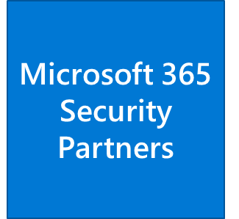
Thank you for your continued trust and partnership. The resources within this toolkit will be iteratively improved upon based on product releases as well as direct feedback from delivered engagements. We encourage you to provide feedback to help us improve our products and toolkits.
Please share your feedback and questions via our Engagement feedback form that can be found at: https://aka.ms/SCIEngagementsFeedback.

Introduction
The Data Security Check is an integral part of the Data Security Envisioning Workshop. At its core, the Data Security Check’s objective is to surface hidden data security risks related to behavior of employees and organizational insiders. The Data Security Check leverages Microsoft 365 tools and services in an automated process that will report on risky behavior that may impose data security risks to the organization.
The Data Security Check can be extended with optional modules that will be added as new products become available.
This document contains delivery guidance for the Communication Compliance activity that will extend the Automated Discovery process to identify corporate policy violations or unwanted behavior that can contribute to insider risks within the customer’s organization.
The outcome and findings of this activity will be merged into the overall findings and recommendations that will be presented at the end of the engagement.

Objectives
The objectives for this activity are:
- Discover corporate policy violations or unwanted behavior that can contribute to insider risks by evaluating user communication inside the organization.
Gain visibility into existing, and at sometimes hidden, risks that may exist in the communication that is happening between users internal to the organization.
- Understand how to mitigate identified risks.
Help customers to better understand, prioritize, and mitigate the identified risks.
- Provide recommendations and define next steps.
Recommendations and next steps based on the findings from this activity will be rolled up into the overall Data Security Envisioning Workshop close-out presentation.

Delivery guidance
This document is an integral part of the overall delivery guidance for the Data Security Envisioning Workshop. When delivering the Data Security Check, follow the guidance provided in the <00-Master Delivery Guide> and when instructed, engage in the supplemental activities outlined in this guide.
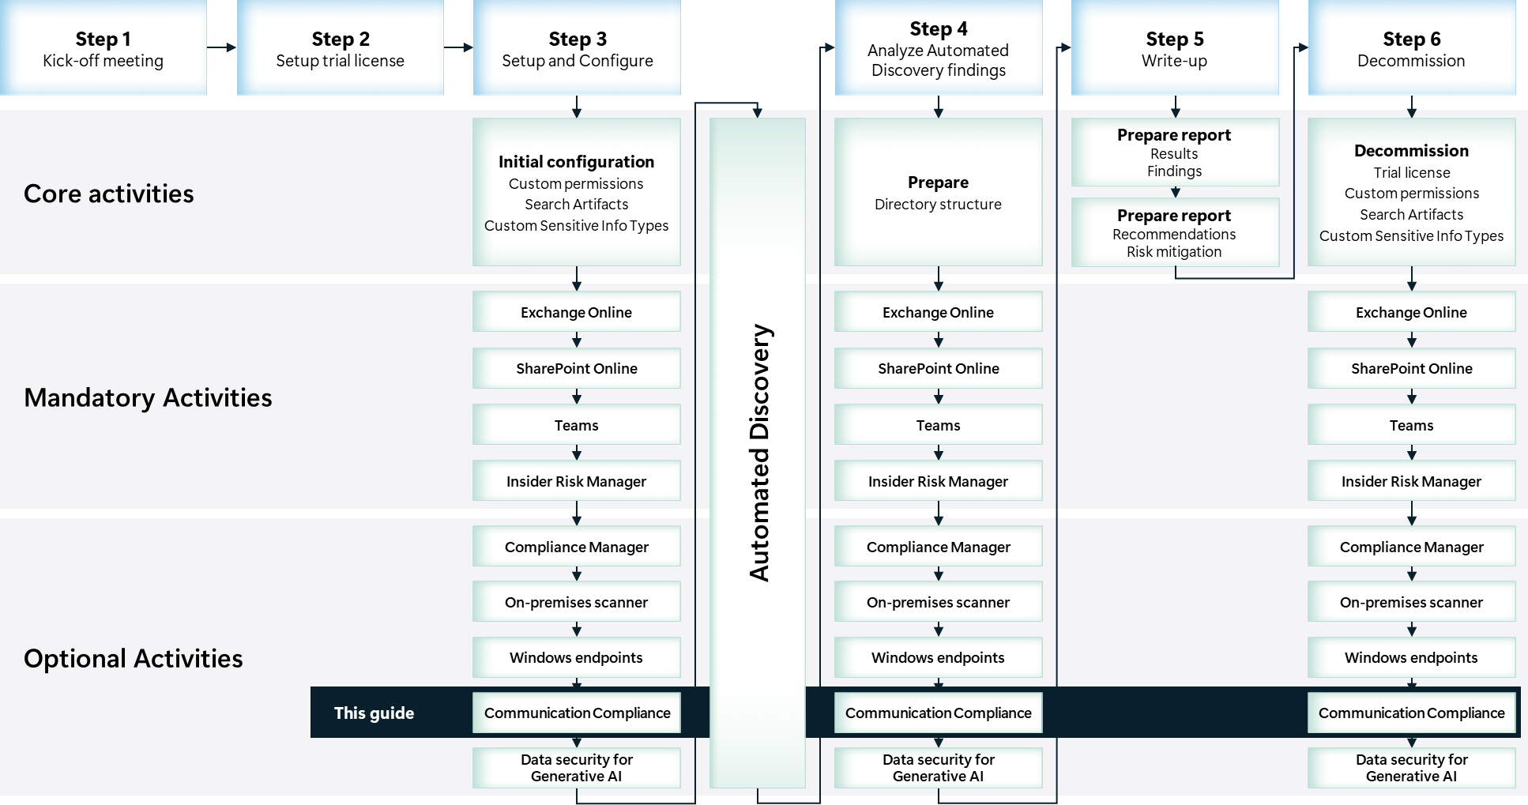

Scoping

In scope
The scope for this activity includes:
- Install and configure the Microsoft Purview Communication Compliance service.
- Evaluate internal communication for the presence of, for example, inappropriate text or sensitive information.

Estimated partner effort
The table below provides a high-level estimate of the additional partner effort for the activities described in this guide. The numbers provided are to be considered indicative and can change as a result of customization of the delivery schedule and the individual activities.
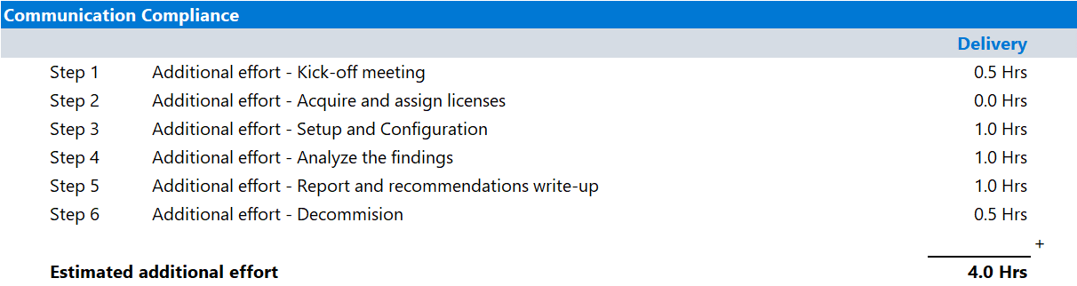

Tools and services used
The Data Security Check Automated Discovery process leverages Microsoft Purview Communication Compliance to discover and report on privacy and regulatory requirements contained in end-user communication within the organization.

Overview
Communication Compliance is an insider risk solution that is part of the Microsoft Purview suite of products. It helps minimize communication risks by helping the customer’s team detect, capture, and take remediation actions for inappropriate messages in the customer organization. Pre-defined and custom policies allow the customer to scan internal and external communications for policy matches so they can be examined by designated reviewers. Reviewers can investigate scanned email, Microsoft Teams, Yammer, or third-party communications in the organization and take appropriate actions to make sure they are compliant with the organization’s message standards.

Product information
- For detailed information refer to Learn about Communication Compliance.

Functionality used by the Data Security Check
The Data Security Check will provide instructions to configure the customer’s environment for the following common compliance scenarios:
- Detect inappropriate text: Uses Microsoft’s machine learning model and multiple built-in trainable classifiers to find and prevent instances of inappropriate language being sent in communications.
- Monitor communications for sensitive information: Monitors communications containing sensitive information to help prevent unauthorized leaks.
- Monitor for conflict of interest: Monitors communications between two groups of users to help avoid conflicts of interest.

Modular setup, mandatory and optional activities
The Communication Compliance module for the Data Security Check is designed in a modular setup containing both mandatory and optional activities:
- Mandatory activities are required to successfully deliver Communication Compliance and must be delivered.
Mandatory activities include:
  - Enabling supporting services, assigning user permissions, and implementing the required configuration.
  - Configure and enable policies to support the Inappropriate text scenario.
  - Configure and enable policies to support enable the Sensitive information scenario.
  - Analyzing and documenting findings.
- Optional activities can be added to the engagement depending on the customer’s needs and requirements. Optional activities available:
  - Configure and enable policies to support the Conflict of interest scenario.
The illustration below provides a high-level overview of the activities that are part of the Communication Compliance module. Mandatory activities are depicted in blue, optional scenarios in yellow. For more details, refer to the upcoming paragraphs.
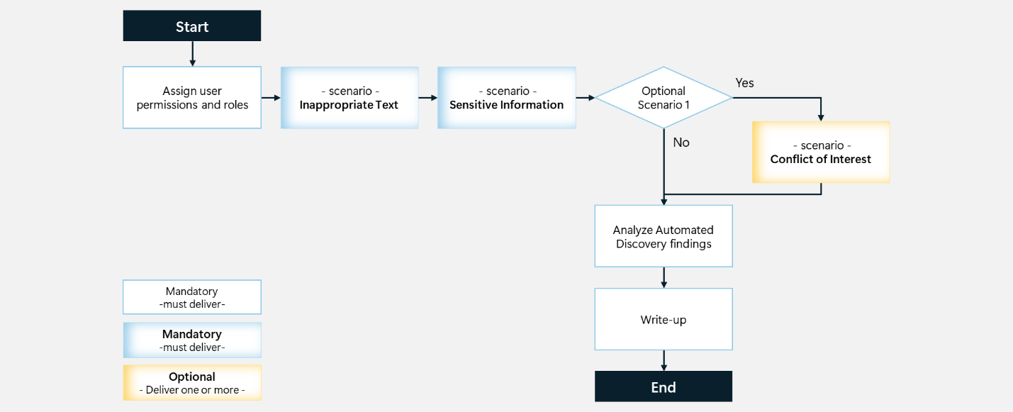

Mandatory activity—Enable the Inappropriate text scenario
The Automated Discovery process will leverage Communication Compliance to monitor the communication of a subset of organizational users for the presence of inappropriate messages. In the case inappropriate messages are detected, alerts will be generated on the Communication Compliance dashboard.
For more information refer to: Case study - Contoso configures a Communication Compliance policy to identify potentially inappropriate text.

Mandatory activity—Enable the Sensitive information scenario
A Communication Compliance policy will be defined that will scan communications of a subset of users for the presence of sensitive information. Both generic, Out-of-box Sensitive Info Types such as credit card numbers, bank accounts, or social security numbers and Custom Sensitive Info Types that align with specific customer requirements, are supported.

Optional activity—Enable the Conflict of interest scenario
To support the Conflict of interest scenario, a policy will be created that monitors communications between two groups or two users to help avoid conflicts of interest.

Activity details

Step 1 - Kick-off meeting

Guidance
Follow the guidance for the Kick-off meeting provided in the <00-Master Delivery Guide> and add an additional section to the meeting(s) to discuss:
- Capabilities and search artifacts for Communication Compliance.
- The privacy aspects of using the Communication Compliance service.
- The users to include in the Communication Compliance Automated Discovery process.
- The mandatory scenarios that will be implemented.
- The optional scenario(s).
The Pre-engagement and Kickoff deck contains optional slides with speaker notes that can be used to facilitate the discussion.

Supporting materials
- <40-Pre-engagement and Kickoff deck>
Note
The <40-Pre-engagement and Kickoff deck> is used for both the Pre-engagement and the Kick-off meeting. Instructions on how to update the slides are included as hidden slides in the deck.

Next step
- Return to the <00-Master Delivery Guide> and continue the guidance provided in Step 1 - Kick-off meeting.

Step 2 - Acquire and assign licenses
The required product licenses for this activity are included in the overall Data Security Check trial license that was deployed in Step 2 - Acquire and assign licenses of the <00-Master Delivery Guide>. No additional (trial) licenses are required.
 Important
Users included in Communication Compliance policies must be assigned a license from the overall Data Security Check trial license.

Background reading
For more information refer to:
- Subscriptions and billing

Step 3 - Setup and configuration

Guidance
This section describes the steps required to install, configure, and run Communication Compliance as part of the Data Security Check Automated Discovery.
Communication Compliance is configured with policies that specify supervised users and reviewers and define which types of risk indicators are configured for alerts. Before activities can trigger alerts, a policy that aligns to a usage scenario must be configured.
The guidance below provides instructions on how to enable policies to support the following scenarios for Communication Compliance:
- Detect Inappropriate text
- Monitor for Sensitive information
- [Optional] Monitor for Conflict of interest
For the Communication Compliance module, the Inappropriate text and Sensitive information scenario will always be implemented. Additionally, the customer can choose to implement the optional scenario(s).
 Important
The partner should work with the customer to understand the privacy impacts of deploying these technologies in a short evaluation mode via the engagement, and if any exist, ensure appropriate safeguards are in place to protect the users.

Background reading
For more information, refer to:
- Learn about communication compliance

Pre-requisites
Prior to starting the activities in this step, the following mandatory Data Security Check activities as described in <00-Master Delivery Guide> should be completed:
- Step 1 - Kick-off meeting
- Step 2 - Acquire and assign licenses
- Step 3 - Setup and configuration

Assign permissions

Guidance
There are five role groups used to configure permissions to manage Communication Compliance features.
- Communication Compliance
- Communication Compliance Administrators
- Communication Compliance Analysts
- Communication Compliance Investigators
- Communication Compliance Viewers
For the Data Security Check engagement, all team members will be assigned to the Communication Compliance role group. This role group contains all the Communication Compliance permission roles and provides the easiest way to quickly get started with Communication Compliance.
Note
In a production setting, it is recommended to assign users to specific role groups to manage different sets of Communication Compliance features.

 Important
Assigning all Data Security Check team members to the Communication Compliance group will, in some regions of the world, be subject to privacy laws and impacted by labor laws and regulations. It is recommended to discuss this with the customer prior to implementation.

Objective(s)
- Add the relevant administrators to the Communication Compliance role group.

Background reading
For more information refer to:
- Assign permissions in Communication Compliance

Instructions
- Browse to the Microsoft Purview portal at https://purview.microsoft.com/ and log in with Tenant Admin credentials or an account that is assigned the global admin role.
- In the navigation bar on the left side, click on Settings.
- On the Settings card, expand Roles and scopes.
- Below Roles and scopes, click on Role groups.
- On the Role groups for Microsoft Purview Solutions page, search for Communication Compliance.
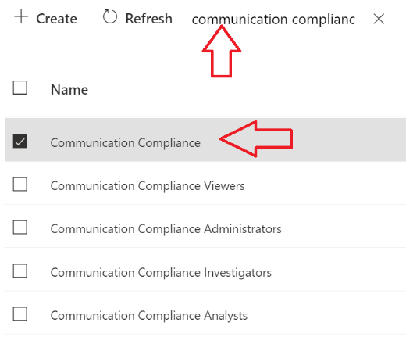
- Click on Communication Compliance.
- On the Communication Compliance flyout, click Edit.
- On the Edit members of the role group page, click on Choose users.
- On the Choose users flyout, select all the Data Security Envisioning Workshop team members that should be assigned the Communication Compliance role.
- On the Choose users flyout, click Select.
- On the Edit members of the role group page, click Next.
- On the Review the role group and finish page, click Save.
- Click Done.

Note
It may take up to 30 minutes for the roles assignments to take effect.

Confirm privacy settings

Guidance
The Communication Compliance solution provides a tenant level option to help customers facilitate internal governance at the user level. Protecting the privacy of users that have policy matches is important and the delivery partner should work with the customer to understand the privacy impacts of deploying these technologies and ensure appropriate safeguards are in place to protect the users.
Note
For the purposes of the Data Security Check, it is recommended that keeping identity anonymized is enabled in order to manage the privacy implications of the Data Security Envisioning Workshop in the customer environment. More information about privacy settings can be found here: Privacy.

Objective(s)
- Verify the privacy settings for Communication Compliance.

Pre-requisites
- All activities described in the previous section have been completed.

Background Reading
- Privacy

Instructions
- Browse to the Microsoft Purview portal at https://purview.microsoft.com/ and log in with Tenant Admin credentials or a user account that is a member of your Data Security Check team and has been assigned the appropriate permissions.
- In the navigation bar on the left side, click on Settings.
- On the Settings card, below Solution settings, click on Communication Compliance.
- On the Communication Compliance settings page, click on Privacy.
- On the Privacy page, verify Show anonymized versions of usernames is enabled.
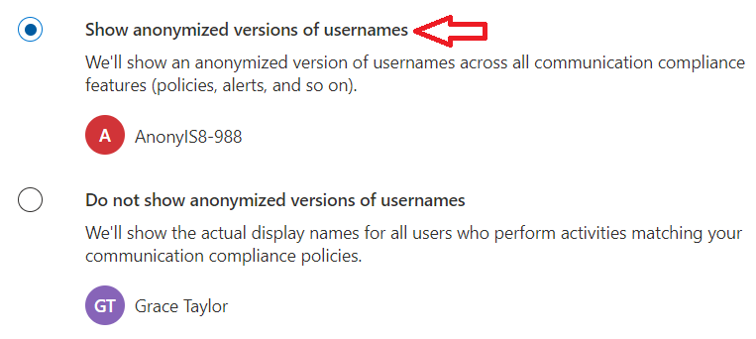

Set up groups for Communication Compliance

Guidance
Users must be assigned to a compliance policy to have their communications reviewed. Additionally, special permissions must be granted to users that will be reviewing the findings. For the Data Security Check, a dedicated group will be created that will control communication review. Members of this group will be subject to communication monitoring as part of the Data Security Check.

Objective(s)
- Create a distribution list to support the implementation of Communication Compliance.
- Assign users to the list.

Pre-requisites
- All activities described in the previous section have been completed.

Background Reading
- Step 3 (optional): Set up groups for Communication Compliance
- Create and manage distribution list groups in Exchange Online

Instructions
- Browse to the Microsoft 365 admin center at https://admin.cloud.microsoft and log in with Tenant Admin credentials or a user account that has been assigned the appropriate permissions.
- In the left-hand menu, expand Teams & groups and click on Active teams & groups.
- On the Active Teams and groups page, select the Distribution list tab.
- Click on Add a distribution list.
- On the Setup the basics page, name the group DataSecurityCheck-CC-MonitoringGroup and provide a meaningful description.
- Click Next.
- On the Assign owners page, click + Assign Owners.
- On the Assign owners fly out, Select a member (or members) of the Data Security Check team that will be designated as group owners.
- Click Add.
- Click Next.
- On the Add members page, click on +Add members.
- Select all users whose communications should be supervised during the Data Security Check engagement, click Add.
- Click Next.
- On the Edit settings page, enter ccmonitor below Group email address.
- Below Communication verify Allow people outside of… is unchecked.
- Click Next.
- On the Review and finish adding group page, click Create group.
- On the New group created page, click Close.

Note
It can take up to one hour for the settings to go into effect and the new group can be used to configure Communication Compliance.

Create the Inappropriate text policy

Guidance
This paragraph provides instructions on how to create a Communication Compliance policy that uses built-in trainable classifiers to detect content containing inappropriate language.

Objective(s)
- Create a Communication Compliance policy for the Inappropriate text scenario and assign users and risk indicators.

Background reading
- Case study - Contoso configures a Communication Compliance policy to identify potentially inappropriate text

Instructions
- Browse to the Microsoft Purview portal at https://purview.microsoft.com/ and log in with Tenant Admin credentials or a user account that is a member of your Data Security Check team and has been assigned the appropriate permissions.
- In the navigation bar on the left side, click on Solutions
- In the Solutions navigator, click on Communication Compliance.
- On the Communication Compliance solution card, click on Policies.
- On the Policies page, click + Create policy
- Select Detect inappropriate text from the drop-down menu.
- On the Detect communications for inappropriate text fly-out, below Policy name, enter DataSecurityCheck-InappropriateText as the name of the new policy.
- Below Users or groups in scope, choose Select users.
- Below Select users, type DataSecurityCheck-CC-MonitoringGroup.
- Below Reviewers, provide the names of the person(s) from the Data Security Check team that will be reviewing possible findings.
- Below Preserve policy matches, leave the setting unchanged.
- Below Settings we’ve filled in for you, review the settings. If needed, click Customize policy to make changes to the policy.
- Click Create policy.
- On the Your policy was created page, click Close.

Note
It can take up to one hour for the policy to go into effect and 24 hours before reviewable alerts are generated. The status of a policy can be checked in the policy overview for Communication Compliance (Activating à Active).

Create the Sensitive information policy

Guidance
This section provides instructions on how to create a Communication Compliance policy that monitors communications for sensitive information. The policy will use both Out-of-box Sensitive Info Types that are included with Microsoft 365 and Custom Sensitive Info Types that are configured to detect customer-specific keywords and information.
The sample instructions provided below will create a policy that monitors communications for the presence of:
- Credit Card Numbers
- U.S. Bank Account Numbers
- ABA Routing Numbers
- Customer specific info types

Important
The above Sensitive Info Types are used for illustration only and might not be applicable if your customer is in a different region or different industry. When delivering the Communication Compliance module you are encouraged to work with your customer to identify and define info types that are relevant to them.

Objective(s)
- Create a Communication Compliance policy for the Sensitive information scenario and assign users and risk indicators.

Instructions
- Follow the guidance in <00-Master Delivery Guide> to create one or more customer-relevant Sensitive Info Types that will be used for the Sensitive information policy.
- Browse to the Microsoft Purview portal at https://purview.microsoft.com/ and log in with Tenant Admin credentials or a user account that is a member of your Data Security Check team and has been assigned the appropriate permissions.
- In the navigation bar on the left side, click on Solutions
- In the Solutions navigator, click on Communication Compliance.
- On the Communication Compliance solution card, click on Policies.
- On the Policies page, click + Create policy
- Select Detect sensitive info types from the drop-down menu.
- On the Detect communications for sensitive information fly-out, below Policy name, enter DataSecurityCheck-SensitiveInformation as the name of the new policy.
- Below Users or groups in scope, choose Select users.
- Below Select users, type DataSecurityCheck-CC-MonitoringGroup.
- Below Reviewers, provide the names of the person(s) from the Data Security Check team that will be reviewing possible findings.
- Below Preserve policy matches, leave the setting unchanged.
- Below Sensitive info to detect click on Add sensitive info or keyword dictionary.
- On the Sensitive info types fly-out, select the Sensitive Info Types previously identified by you and your customer. Below are some examples:
    - Credit Card Numbers
    - U.S. Bank Account Numbers
    - ABA Routing Numbers
    - Customer specific info types (starting with <DataSecurityCheck->)

Important
The above listed Sensitive Info Types are for illustration purposes only and should be replaced by customer relevant Sensitive Info Types.

- Click Add.
- Below Settings we’ve filled in for you, review the settings. If needed, click Customize policy to make changes to the policy.
- Click Create policy.
- On the Your policy was created page, click Close.

[Optional] Create the Conflict of interest policy

Guidance
This paragraph provides instructions on how to create a Communication Compliance policy that monitors communications between two groups of users across locations like Exchange, Teams, and more.

Objective(s)
- Create a Communication Compliance policy for the Conflict of interest scenario and assign users and risk indicators.

Instructions
- Follow the guidance in paragraph 2.3.3-Set up groups for Communication Compliance and create two additional Distribution Lists, each containing a set of users to monitor:
    - DataSecurityCheck-CC-MonitoringGroupA
    - DataSecurityCheck-CC-MonitoringGroupB
- Browse to the Microsoft Purview portal at https://purview.microsoft.com/ and log in with Tenant Admin credentials or a user account that is a member of your Data Security Check team and has been assigned the appropriate permissions.
- In the navigation bar on the left side, click on Solutions
- In the Solutions navigator, click on Communication Compliance.
- On the Communication Compliance solution card, click on Policies.
- On the Policies page, click + Create policy
- Select Detect conflict of interest from the drop-down menu.
- On the Monitor communications for conflict of interest fly-out, below Policy name, enter DataSecurityCheck-ConflictOfInterest as the name of the new policy.
- Below Scoped group A, type DataSecurityCheck-CC-MonitoringGroupA.
- Below Supervised group B, type DataSecurityCheck-CC-MonitoringGroupB.
- Below Reviewers, provide the names of the person(s) from the Data Security Check team that will be reviewing possible findings.
- Below Preserve policy matches, leave the setting unchanged.
- Below Settings we’ve filled in for you, review the settings. If needed, click Customize policy to make changes to the policy.
- Click Create policy.
- On the Your policy was created page, click Close.

Step 4 - Analyze the findings
In Step 4 of the Data Security Check the partner will, together with the customer’s tenant / Compliance Administrator, analyze all logs, information, and reports generated by the different Data Security Check tools and services. This section describes the additional steps required to prepare and analyze the results from the Communication Compliance activity.
It is recommended to do a two-step analysis of the logfiles, reports, and findings:
- Quick scan. By using the various dashboards and preview views you will be able to identify common patterns and/or trends that need further investigation and can serve as an example of privacy and regulatory risks. Look for “most impactful” events related to important people within the organization, high volumes of documents related to a specific business process, Personally Identifiable Information (PII), etc.
- Detailed analysis. Using exported log and report files for the various services will allow for further investigation of previously identified privacy and regulatory risks and events flagged during the quick scan. Aim at determining the impact and risk and consider viable solutions for mitigation. During this detailed analysis you are advised to leverage the insights of the customer team because they will know what and who to look for. To rule out “false positives” you are advised to do further investigation of all the events that will be included in the final close-out presentation at the end of the engagement.

Objective
- Export risks identified by Communication Compliance for future analysis.

Background reading
For more information refer to:
- Investigate and remediate Communication Compliance alerts

Prepare for analysis—exporting the reports and log files

Guidance
The Communication Compliance user interface offers a case management-focused workflow that assists in adding to policy model accuracy and moving to an investigation. To provide insights into the customer organization, numeric reporting requires extracting results from underlying data sources in the customer’s tenant.
The partner delivering this module may want to consider taking screenshots of the customer environment, if the guiding scope and customer context allow, to demonstrate to the customer how these compliance risks would enable the customer’s internal compliance and HR teams to manage conduct in the enterprise at scale.

Objective(s)
- Export alerts and findings from the Communication Compliance dashboard to highlight communications activities that may represent common risks for the customer.

Background reading
For more information refer to:
- Learn about communication compliance

Instructions
- On the local workstation, if not already done, extend the previously created directory structure by creating the \DataSecurityCheck\CommunicationCompliance folder.
- Browse to the Microsoft Purview portal at https://purview.microsoft.com/ and log in with Tenant Admin credentials or a user account that is a member of your Data Security Check team and has been assigned the appropriate permissions.
- In the navigation bar on the left side, click on Solutions
- In the Solutions navigator, click on Communication Compliance.
- On the Communication Compliance solution card, click on Reports.
- On the Reports page, take screenshots of the following cards:
Cards | Image name
Recent policy matches | DataSecurityCheck-PolicyMatchesRecent.jpg
Policies with most matches | DataSecurityCheck-PolicyMatchesMost.jpg
Users with most policy matches | DataSecurityCheck-PolicyMatchesMostUsers.jpg

- Save the screenshots to the \DataSecurityCheck\CommunicationCompliance folder.
Note
Refer to Use Snipping Tool to capture screenshots for guidance on taking screenshots.

[Optional] Instructions—Export reports for further analysis
If needed, detailed reports can be exported for further analysis in, for example, Excel. Follow the steps below to export relevant reports.
For every report needing further investigation:
- On the Reports page, in the Detailed reports section, click on View details in the report card needing further investigation.
- On the <Report name> page, next to Filters, click Choose a date range and select a data range that aligns with the Data Security Envisioning Workshop delivery time frame.
- Click Export.
- Save the <Report name>.csv file to the \DataSecurityCheck\CommunicationCompliance folder.
- On the top of the <Report name> page, click on Reports to return to the Reports page.

Analyzing discovery findings log files and reports

Guidance
The Communication Compliance findings are exported into multiple CSV files and screenshots.
The contents of these screenshots and files should be analyzed and copied to the placeholder slides in the close-out-presentation <41-Close-out deck>.

Objective(s)
- Analyze the reports for the Communication Compliance activity.

Instructions
Filename: | DataSecurityCheck-PolicyMatchesRecent.jpg
Location | \DataSecurityCheck\CommunicationCompliance
Contains | Graph illustrating the number of policy matches since the policy was activated (depending on data available) in the customer environment.
Usage | Provide a visual depiction of the magnitude of top policies which are matching user behaviors in the customer environment, as well as identify overall trending (up/neutral/down).
Use in close-out deck? | YES
Instructions | - When creating the close-out presentation, copy the graphic to the appropriate slide in the deck.
Sample illustration | 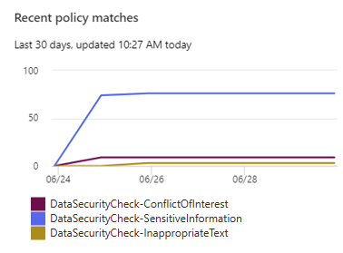

Instructions
Filename: | DataSecurityCheck-PolicyMatchesMost.jpg
Location | \DataSecurityCheck\CommunicationCompliance
Contains | Image of table captured from Microsoft 365 identifying policy names and match counts for the top policies in the customer environment.
Usage | Highlights top potential risks to the customer based on the policies which having the highest occurrence in the organization’s communications, as well as a match count which serves as a proxy to the relative risk of that type of compliance problem.  Note  Until the customer regularly reviews alerts and begins flagging false positives and escalating cases, the model is not tuned for the customer’s use cases and cultural sensitivity. As a result, the raw data does not take false positive rate into account, but rather provides a general indicator to the risk type only.
Use in close-out deck? | YES
Instructions | - When creating the close-out presentation, copy the graphic to the appropriate slide in the deck.
Sample illustration | 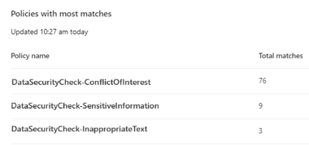

Instructions
Filename: | DataSecurityCheck-PolicyMatchesMostUsers.jpg
Location | \DataSecurityCheck\CommunicationCompliance
Contains | Image of table captured from Microsoft 365 highlighting the top users and the number of matches for customer compliance activations in the customer environment.
Usage | Provide a specific identification of users whose behaviors are triggering the most matches across policies for communications compliance risk in the environment.  Note  In some jurisdictions, identifying specific users in a public context such as a meeting with a client may not be a suitable action. Work with your customer’s legal representatives for the Data Security Envisioning Workshop to determine if this is desirable for the customer presentation.
Use in close-out deck? | YES
Instructions | - Review the identified users with the most policy matches together with the Data Security Envisioning Workshop sponsor at the customer to determine if this graphic should be included in the close-out presentation.  - When creating the closeout presentation, copy the graphic to the appropriate slide in the deck.
Sample illustration | 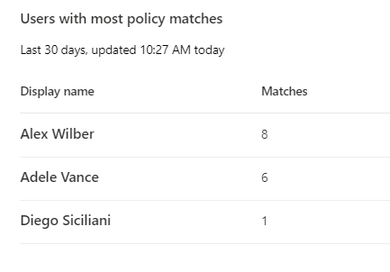

[Optional] Instructions—Analyze exported results
The exported files provide additional detail on identified risks and can be used for further analysis. Import the exported reports into Excel following the instructions in the appendix of the Master Delivery Guide and use pivot tables or advanced sorting to create detailed tables.

Next step
- Return to the <00-Master Delivery Guide> and continue the guidance provided in Step 4 - Analyze the findings.

Step 6 - Decommission

Guidance
The final activity for the Communication Compliance activity is to decommission the services and tools used for this activity.
Important
Do not perform the decommissioning steps, if the customer chooses to do so, until after the Proof of Execution (POE) has been filled out. The POE requires that evidence of the configuration is captured and will not be able to be completed if all of the policies are removed.

Objectives
The objectives for this activity are:
- Decommission the services that were installed to support the Communication Compliance.

Deliverables
For this activity, the following deliverables have been defined:
- All tools and services used during the Communication Compliance module are decommissioned.
- All custom configuration artifacts are removed from the customer’s tenant.

Instructions—Delete the Communication Compliance policies.
- Browse to the Microsoft Purview portal at https://purview.microsoft.com/ and log in with Tenant Admin credentials or a user account that is a member of your Data Security Check team and has been assigned the appropriate permissions.
- In the navigation bar on the left side, click on Solutions
- In the Solutions navigator, click on Communication compliance.
- On the Communication compliance solution card, click on Policies.
- On the Policies page, Search for DataSecurityCheck-.
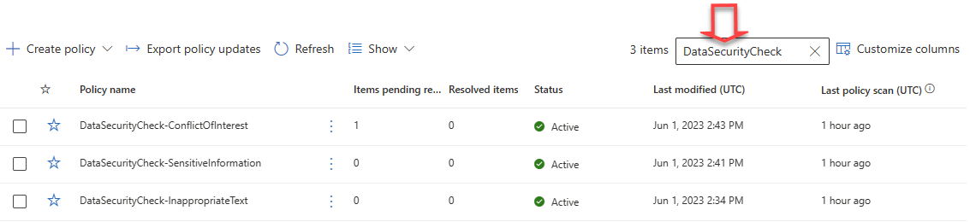
- Individually select all policies created for the Data Security Check and clickto Delete the selected policy.
- On the Delete this policy? fly-out, click Delete.

Instructions—Delete the Data Security Check Distribution groups
- Browse to the Microsoft 365 admin center at https://admin.cloud.microsoft and log in with Tenant Admin credentials or a user account that has been assigned the appropriate permissions.
- In the left-hand menu, expand Teams & Groups and click on Active Teams & groups.
- On the Active teams and groups page, select the Teams & Microsoft 365 groups tab.
- Search for DataSecurityCheck-.
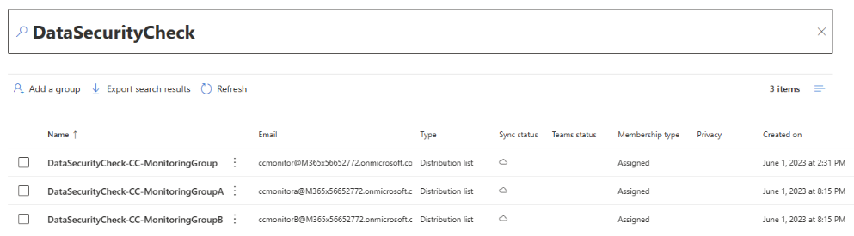
- Individually select all groups created for the Data Security Check and clickDelete group.
- On the flyout, click on Delete Group.
- On the Confirmation page, click Delete group.

Instructions—Remove users from the Communication Compliance Role Group
- Browse to the Microsoft Purview portal at https://purview.microsoft.com/ and log in with Tenant Admin credentials or a user account that is a member of your Data Security Check team and has been assigned the appropriate permissions.
- In the navigation bar on the left side, click on Settings.
- On the Settings card, expand Roles and scopes.
- Below Roles and scopes, click on Role groups.
- On the Role groups for Microsoft Purview solutions page, search for Communication Compliance.
- Click on Communication Compliance.
- On the Communication Compliance fly out, click Edit.
- On the Edit members of the role group page, select all the Data Security Envisioning Workshop team members that were assigned the Communication Compliance role.
- Click on Remove members.
- Click Next.
- On the Review the role group and finish page, click Save.
- Click Done.

Next step
- Return to the <00-Master Delivery Guide> and continue the guidance provided in Step 6 - Decommission.

